The Facade Pattern
Like the Adapter pattern, Facade is known as a structural pattern, as it's used to identifying a simple way to realize relationships between entities. The definition of Facade provided in the original Gang of Four book on Design Patterns states:
Provide a unified interface to a set of interfaces in a subsystem. Façade defines a higher-level interface that makes the subsystem easier to use.
Like the adapter pattern, the Facade can be used to hide the inner workings of a third party library, or some legacy code. All that the client needs to do is interact with the Facade, and not the subsystem that it is encompassing.
The following sequence diagram illustrates how the pattern is used by a client:
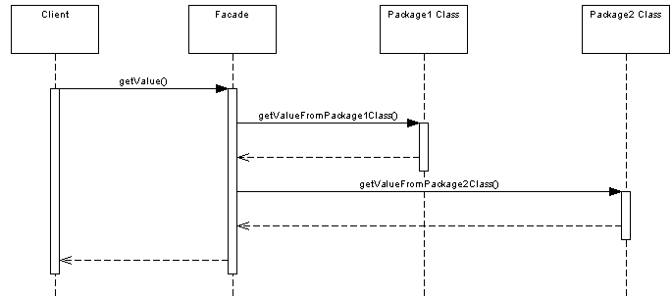

Where Would I Use This Pattern?
As the concept behind facade is to simplify an interface, service oriented architectures make use of the facade pattern. For example, in web services, one web service might provide access to a number of smaller services that have been hidden from the caller by the facade.

So How Does It Work In Java?
Let's take a travel agent site for example, that allows you to book hotels and flights. We have a HotelBooker:
public class HotelBooker
{
public ArrayList<Hotel> getHotelNamesFor(Date from, Date to)
{
//returns hotels available in the particular date range
}
}
And a FlightBooker:
public class FlightBooker
{
public ArrayList<Flight> getFlightsFor(Date from, Date to)
{
//returns flights available in the particular date range
}
}
Both of these have Hotel and Flight data types, which the client has knowledge about. They could be provided in the same package as the Facade for example.
The TravelFacade class allows the user to get their Hotel and Flight information in one call:

public class TravelFacade
{
private HotelBooker hotelBooker;
private FlightBooker flightBooker;
public void getFlightsAndHotels(Date from, Data to)
{
ArrayList<Flight> flights = flightBooker.getFlightsFor(from, to);
ArrayList<Hotel> hotels = hotelBooker.getHotelsFor(from, to);
//process and return
}
}
All that the client needs to worry about is the Facade class:
public class Client
{
public static void main(String[] args)
{
TravelFacade facade = new TravelFacade();
facade.getFlightsAndHotels(from, to);
}
}
As you can see, it's just a simple approach to encapsulating data.

